**ETHNUS**

Building a Face-Detection App on AWS

**NAME: K.DINESH KUMAR**

**REG.NO: 16MIS0286**

**Screenshots for Dashboards**

1. AWS Login screen with username

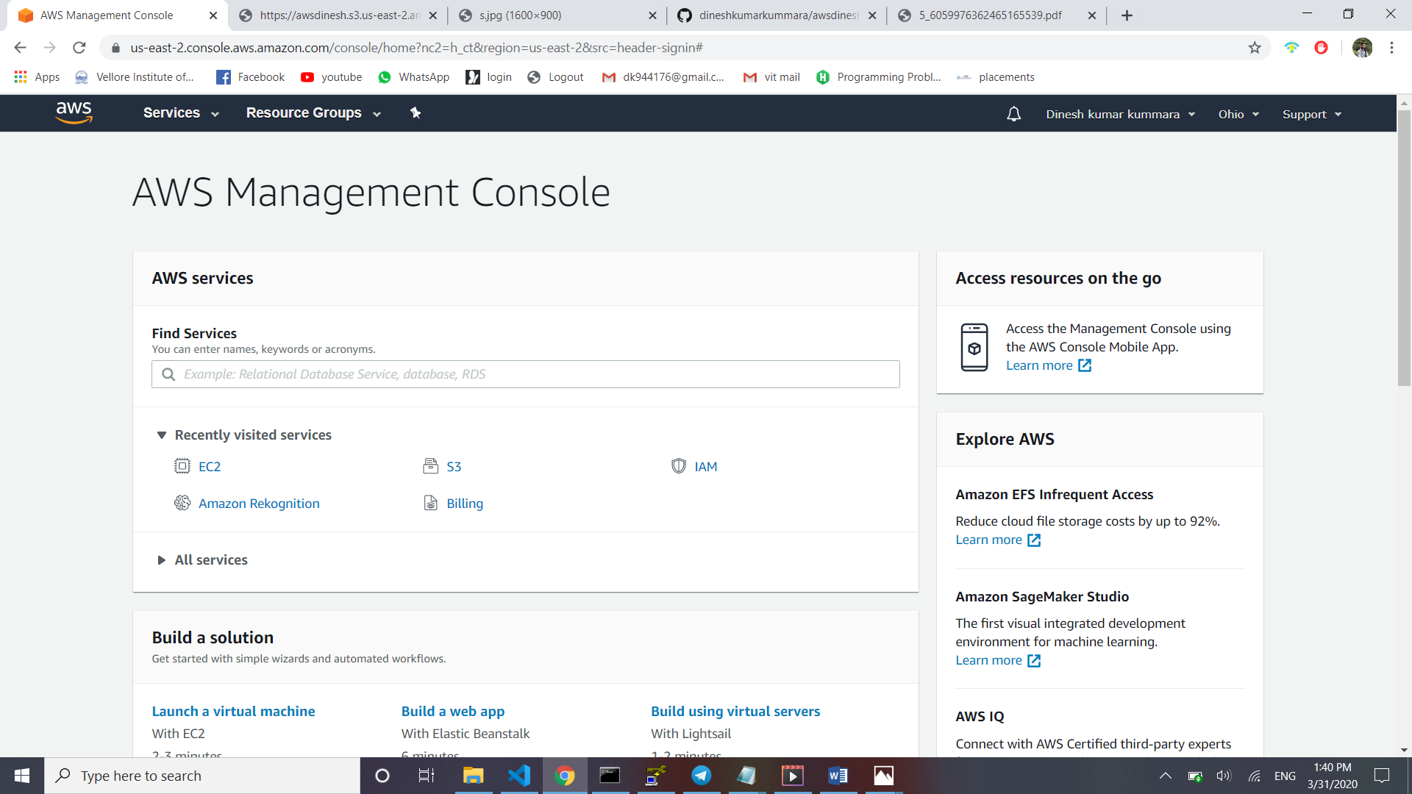

2. EC2 Dashboard

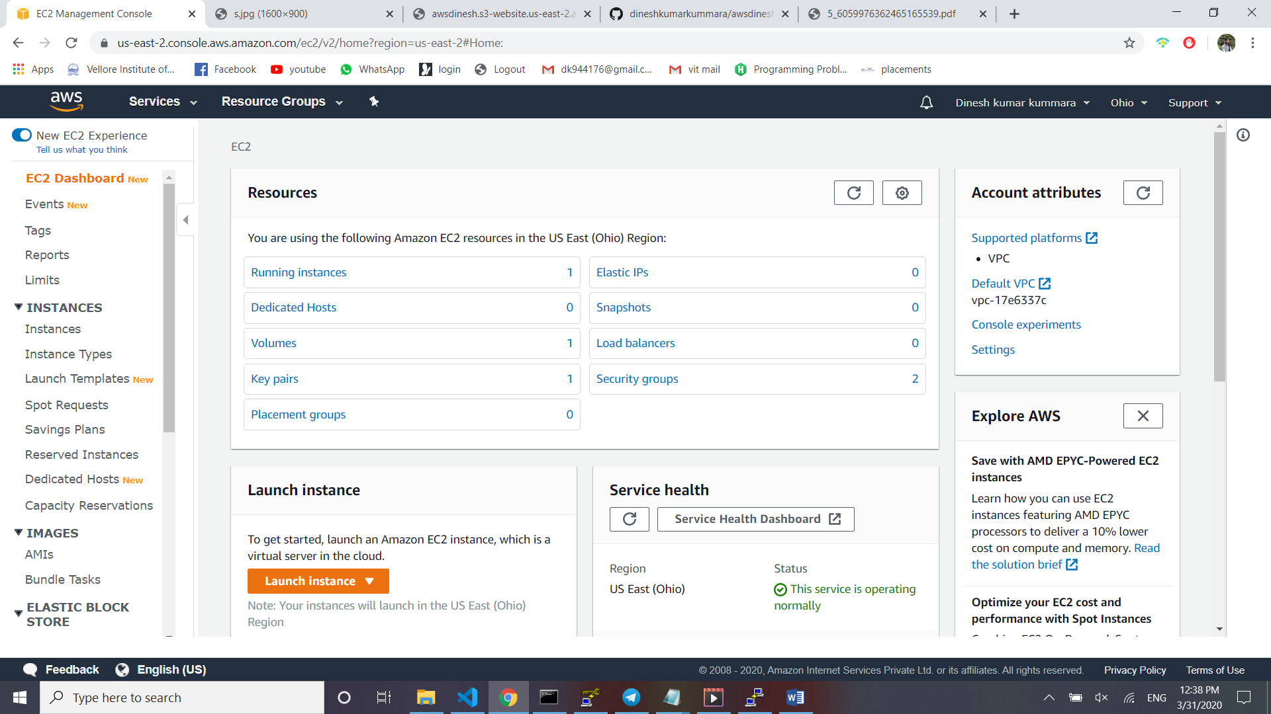

3. S3 Dashboard

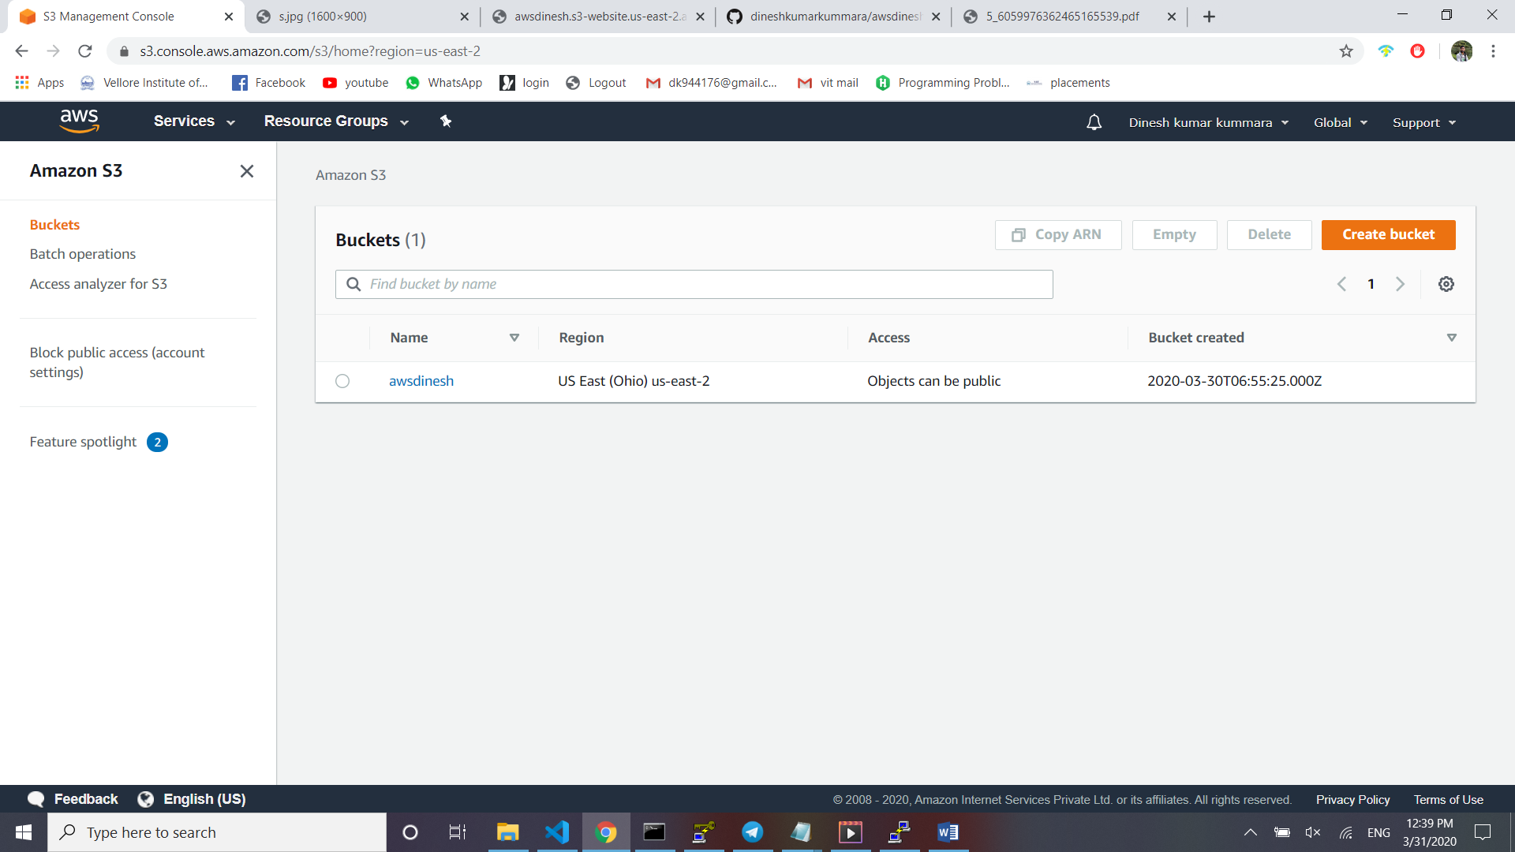

4. Rekognition Dashboard

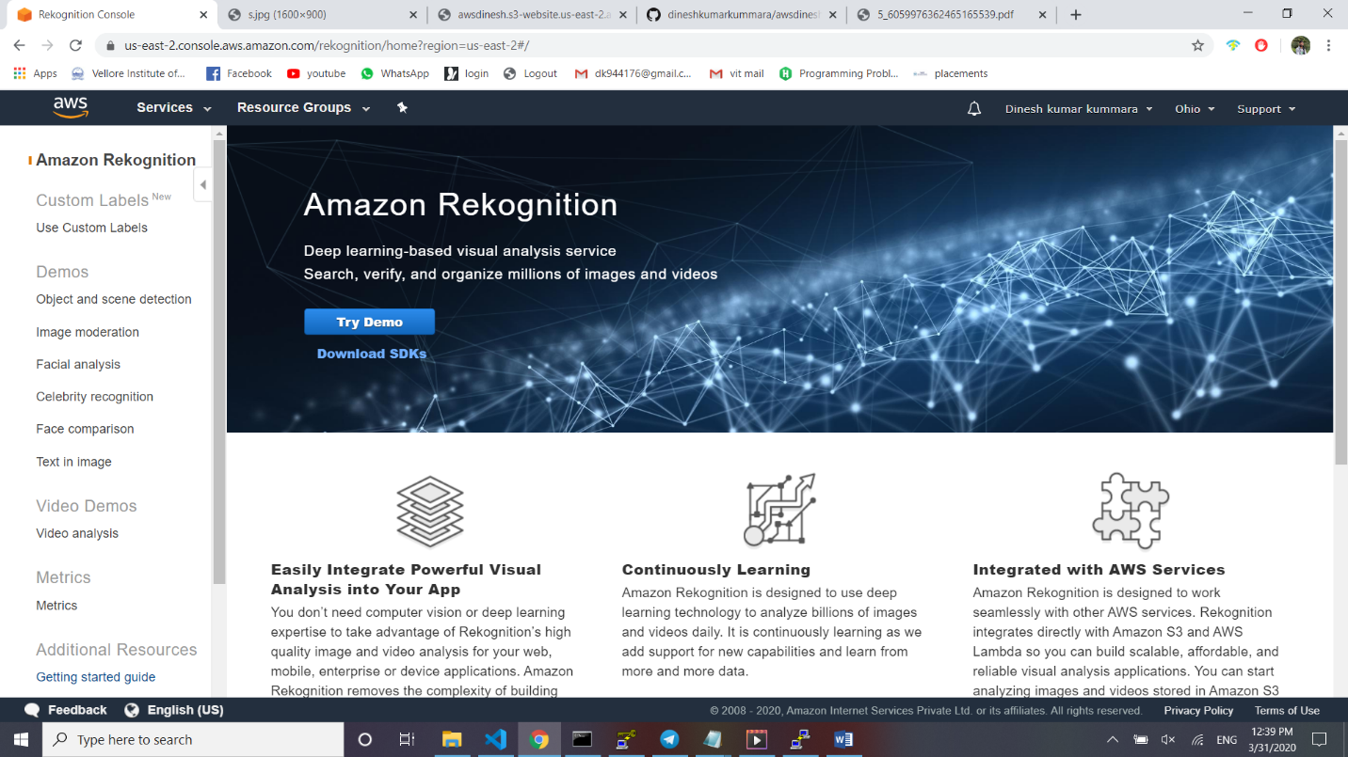

**Screenshots for EC2**

1. Choosing an AMI

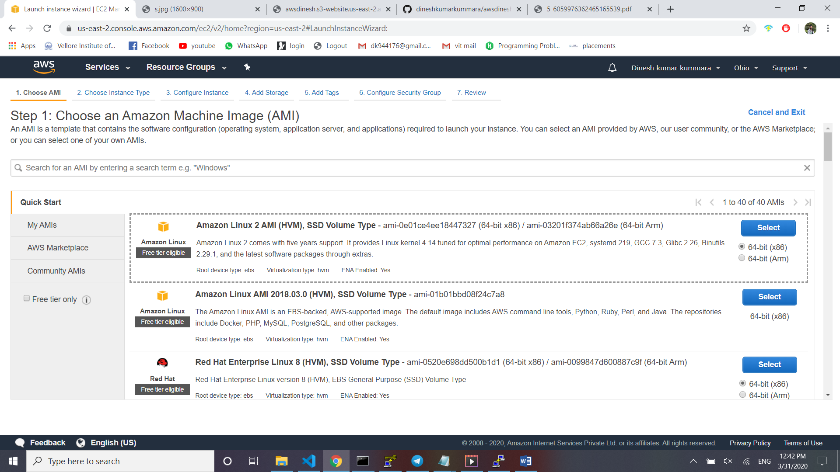

2. Choosing an Instance Type

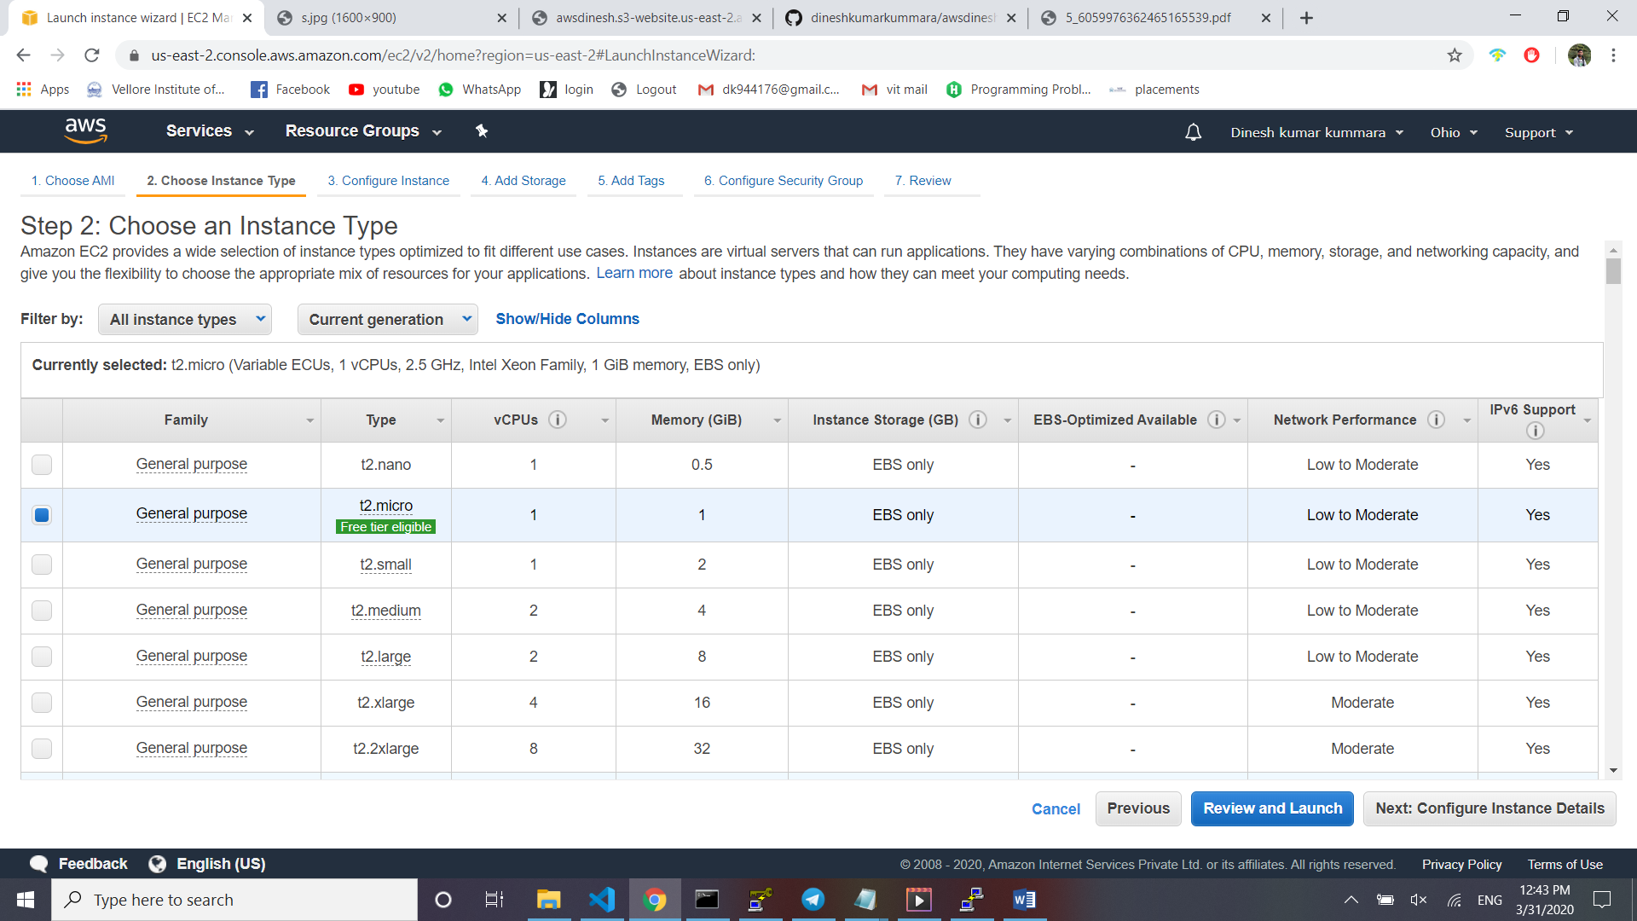

3. Adding Storage

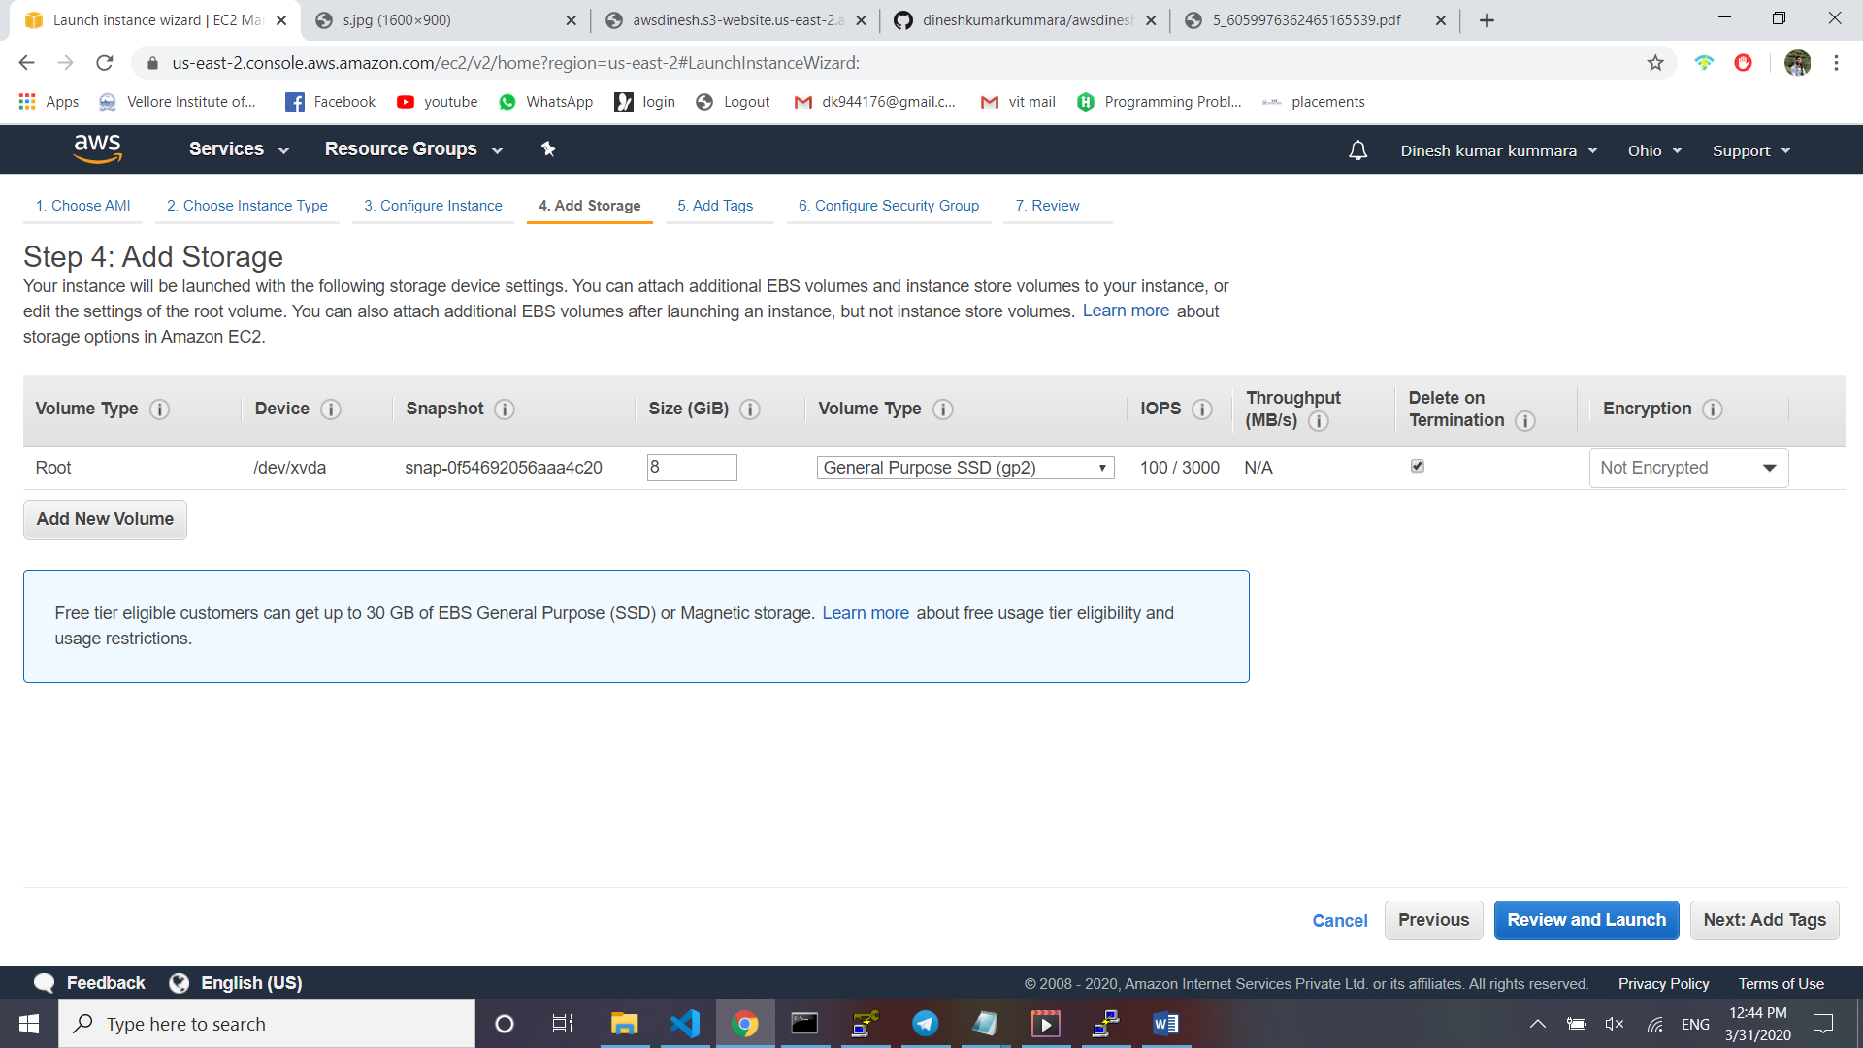

4. Configuring Security Group

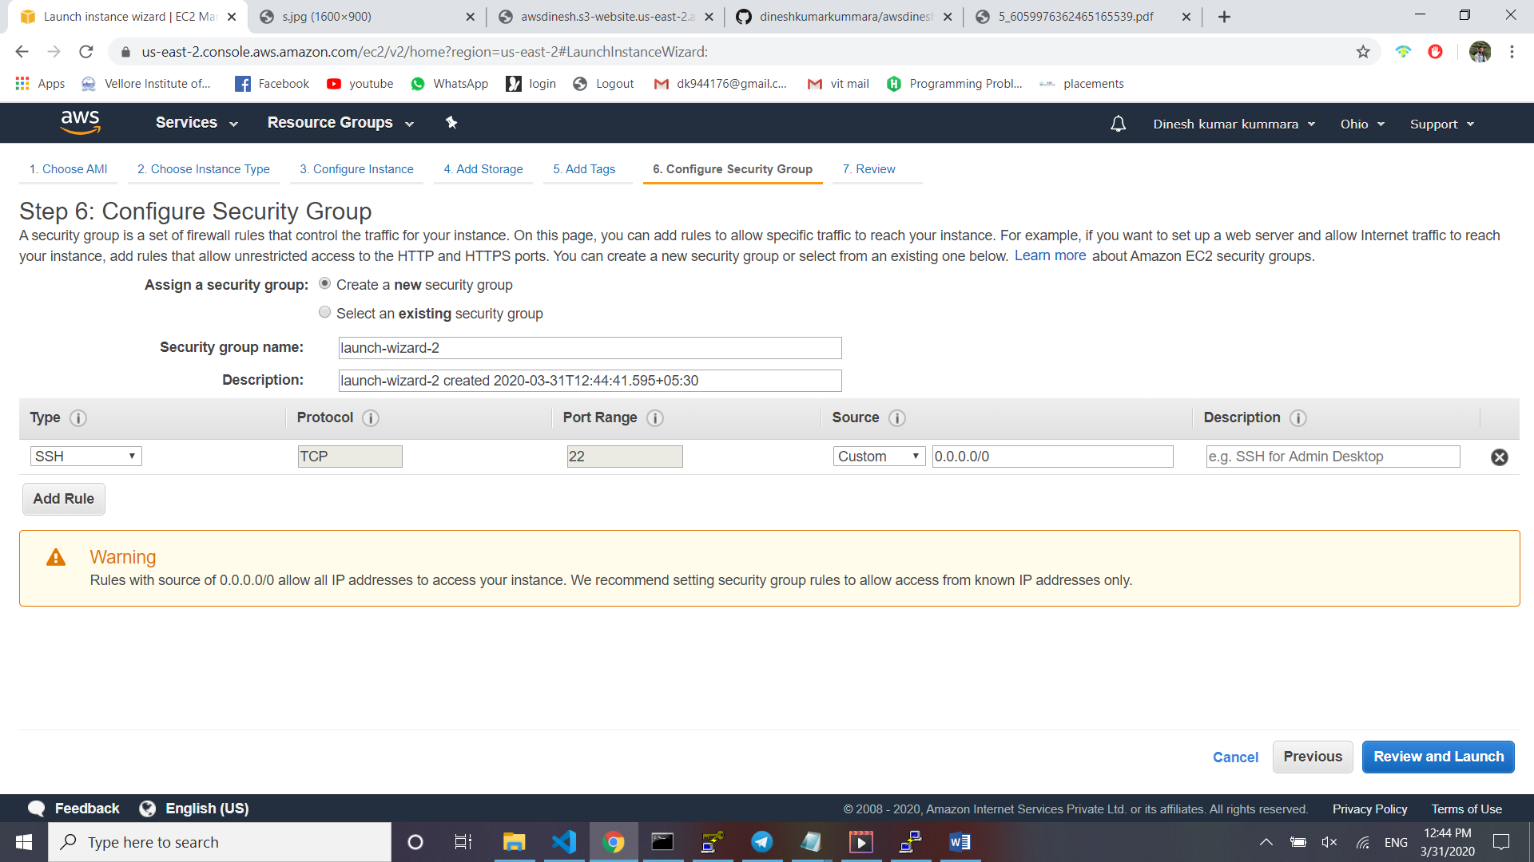

5. Key Pair Download

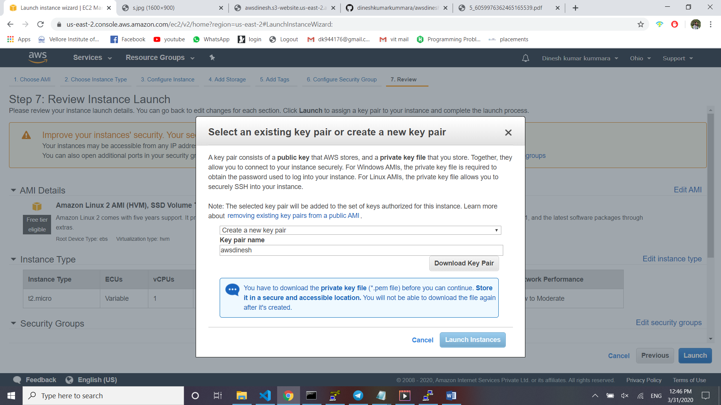

6. PuTTYgen conversion from pem to ppk

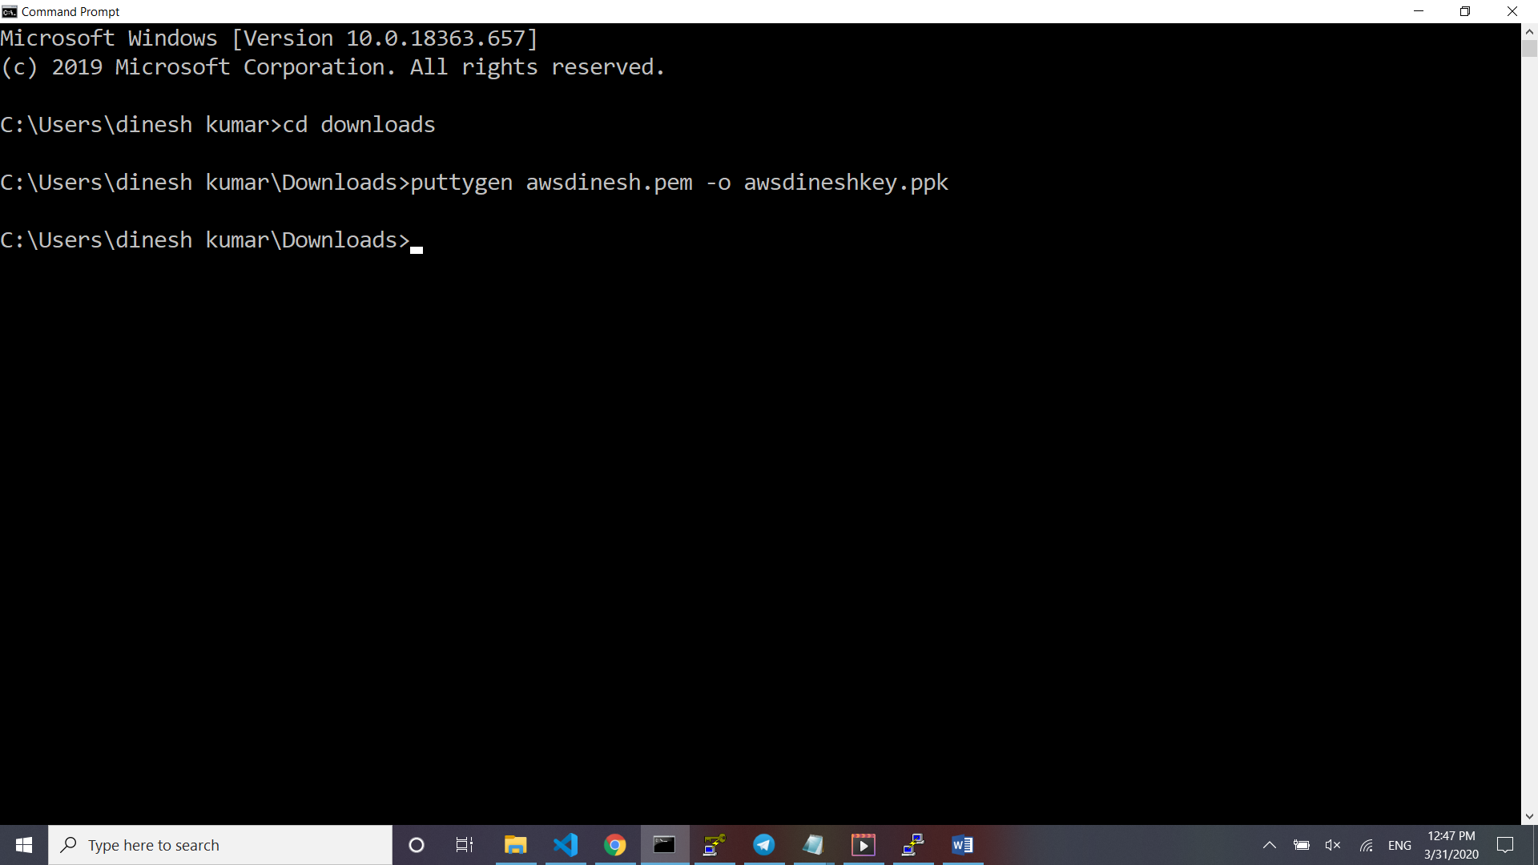

7. Logged in EC2 black screen

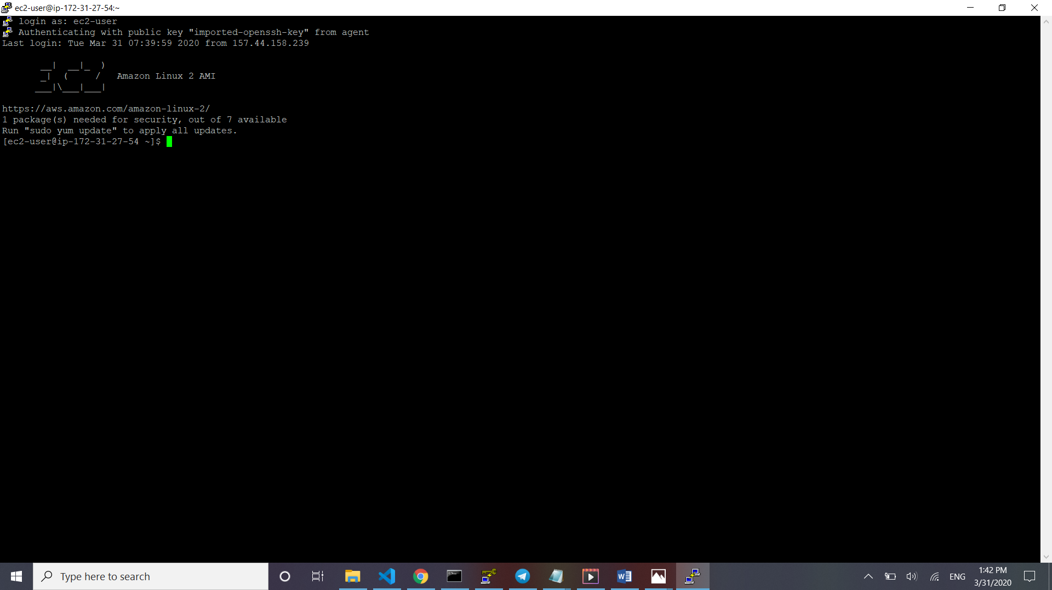

**Screenshots for S3**

1. Creating a bucket

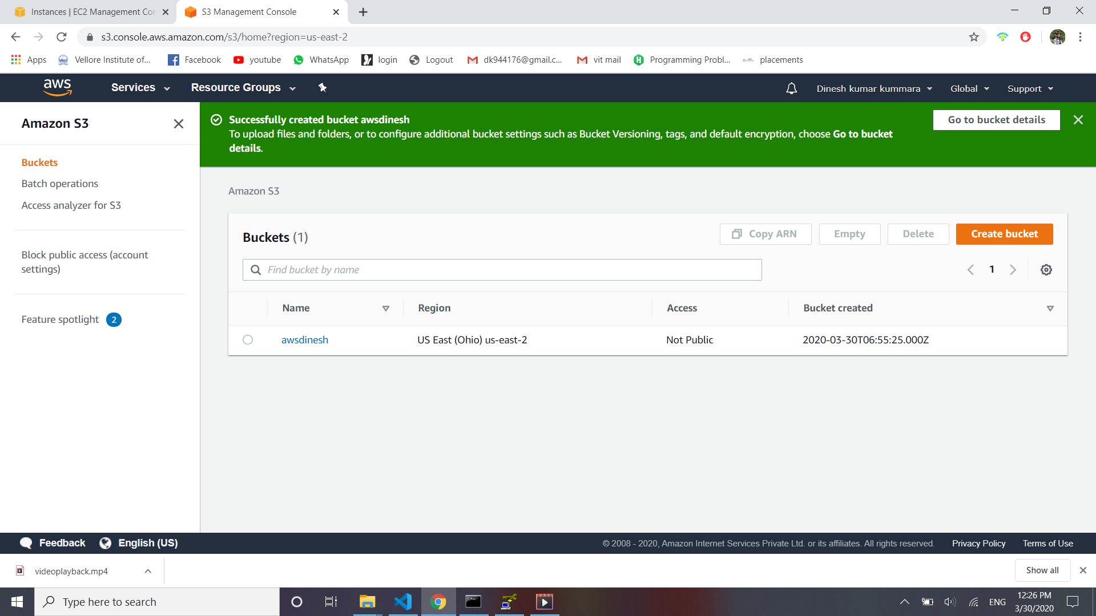

2. Uploading an Object

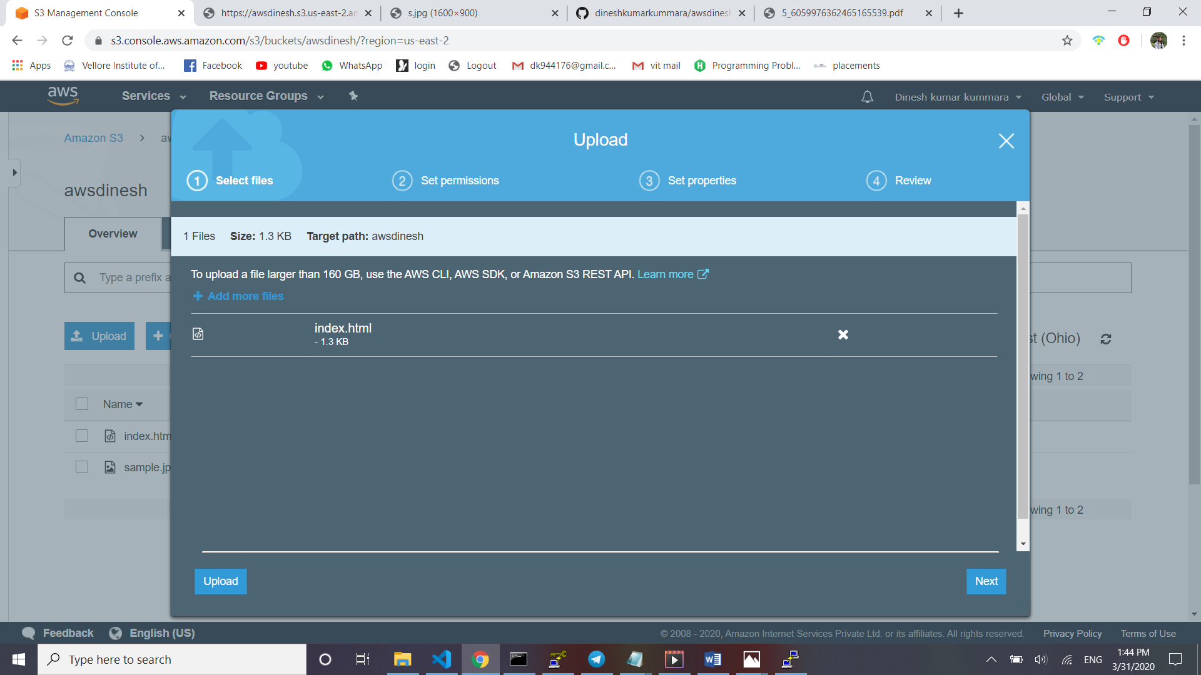

3. Enabling Static Website

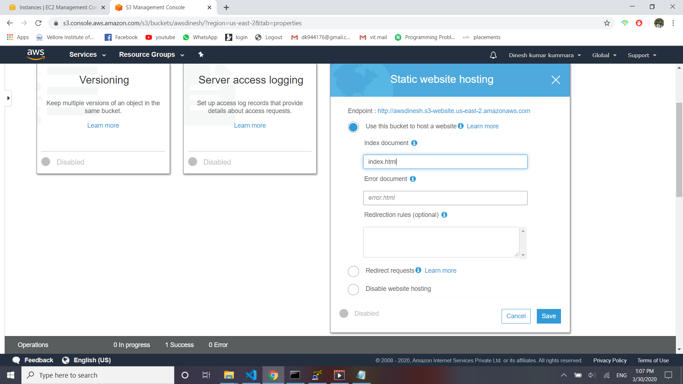

4. Making the Object Public

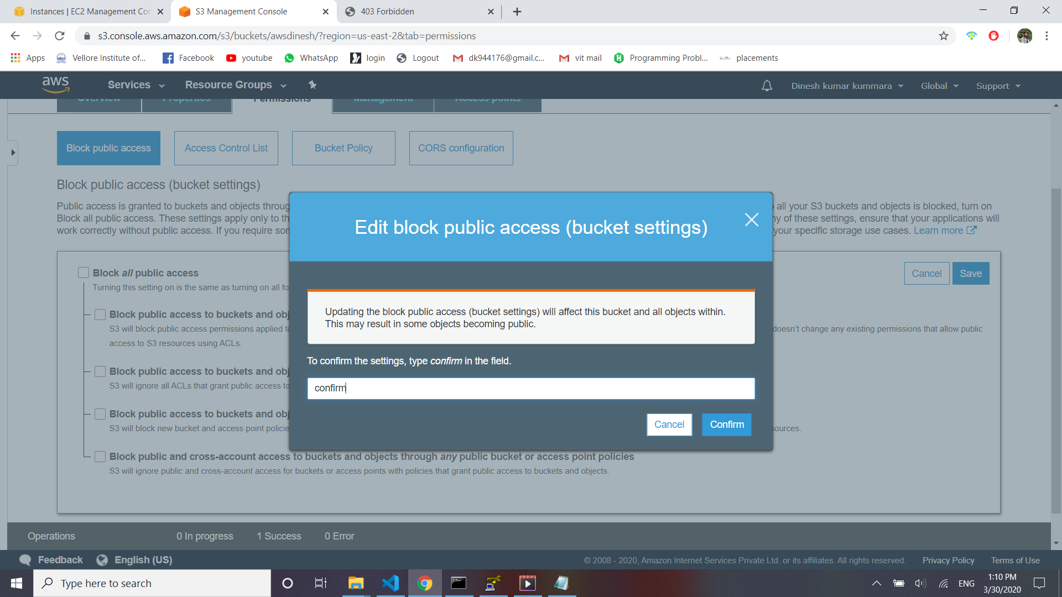

5. Checking the S3 link on the browser

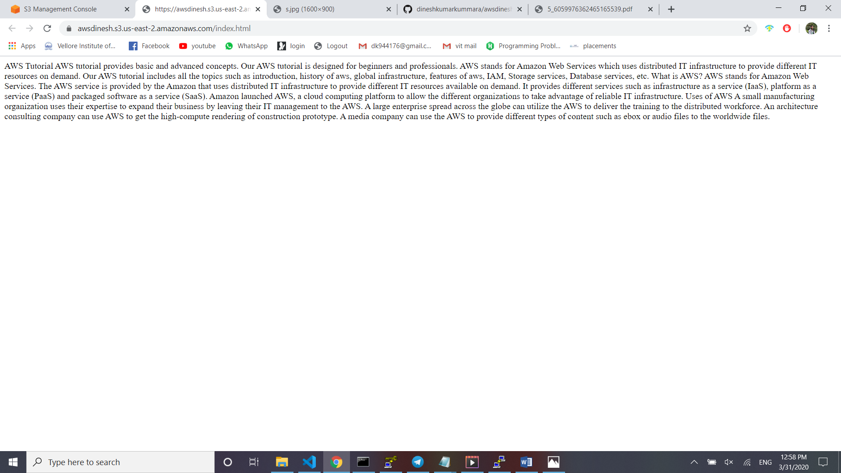

**Screenshots for Rekognition**

1. Face Detect

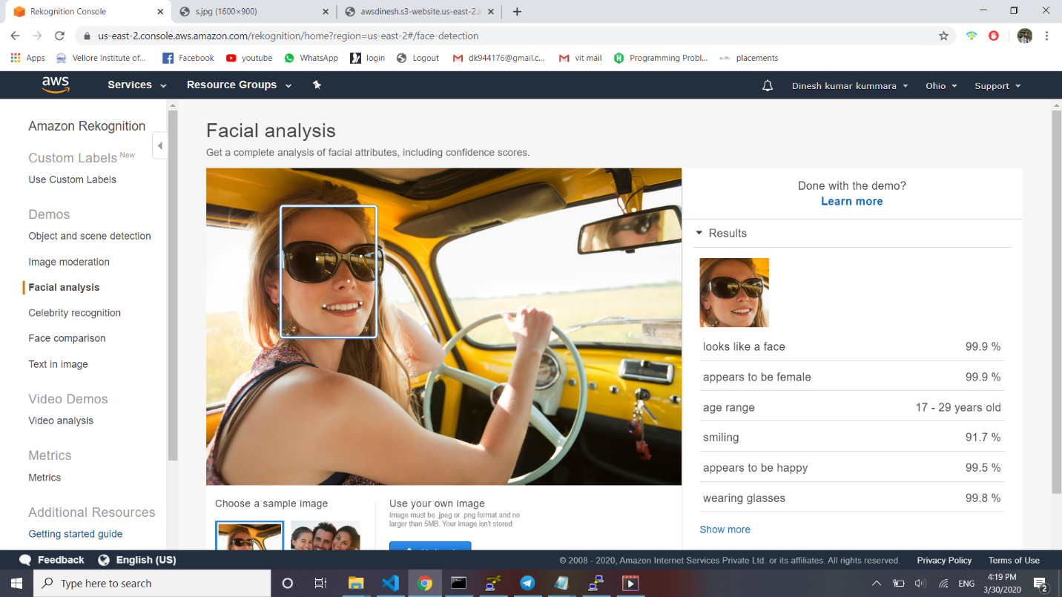

2. Face Compare

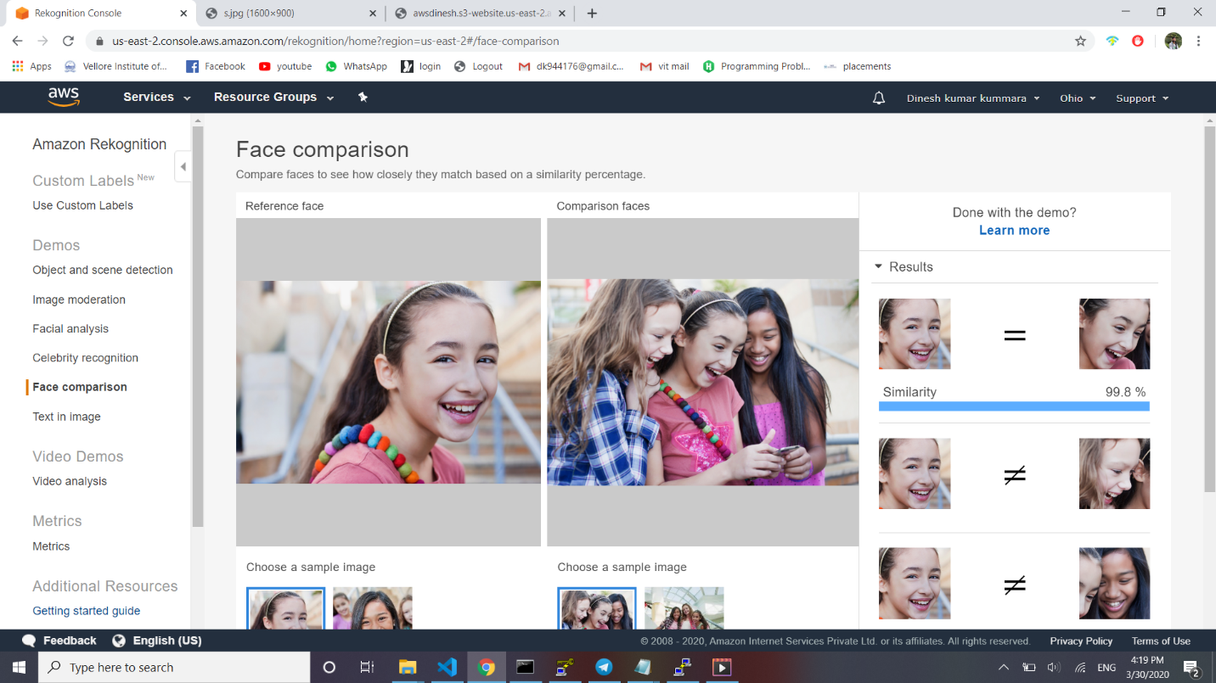

3. Celebrity Recognition

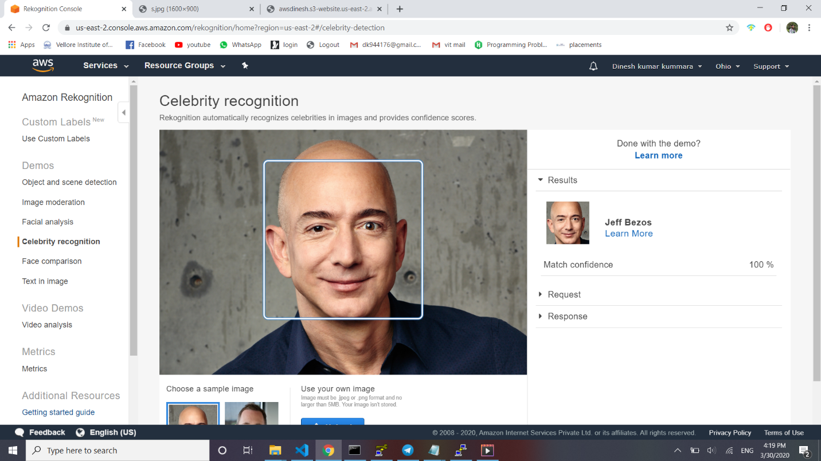

4. Text in Image

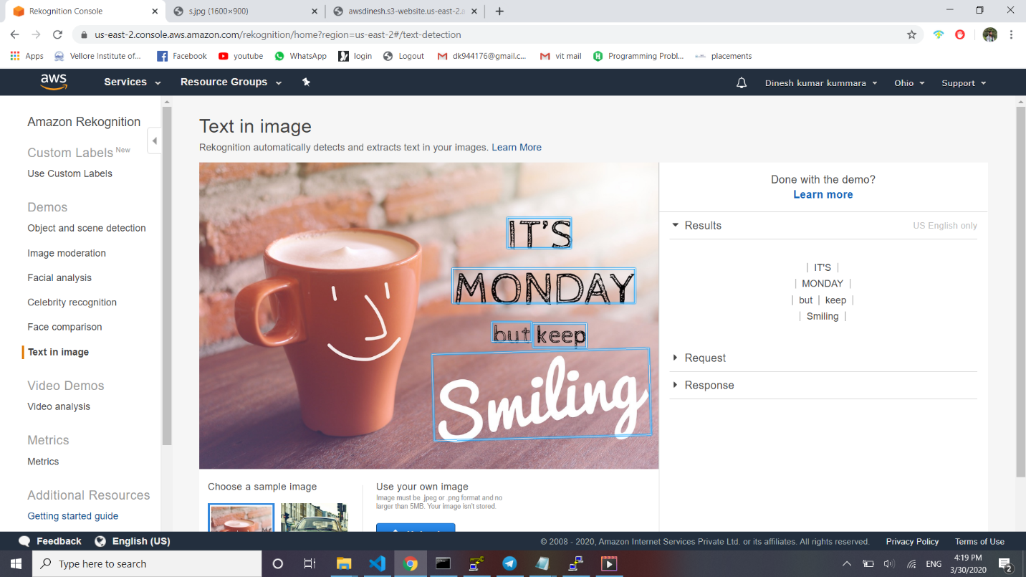

**Screenshots for EC2 & S3**

1. Installing aws-sdk

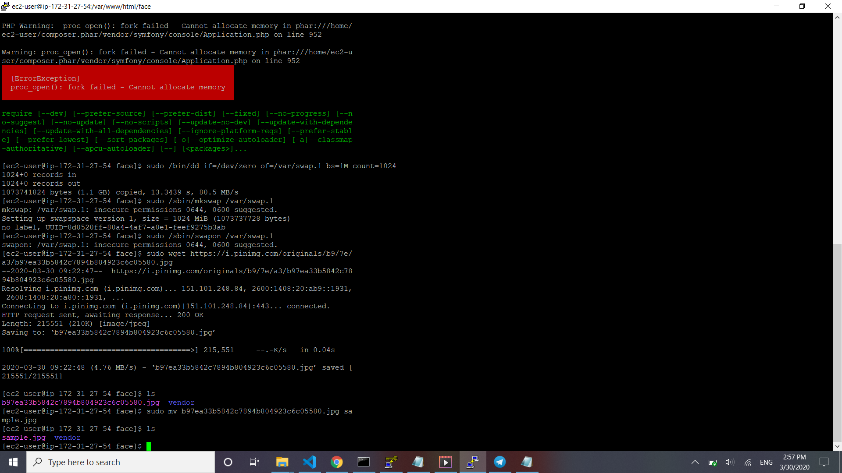

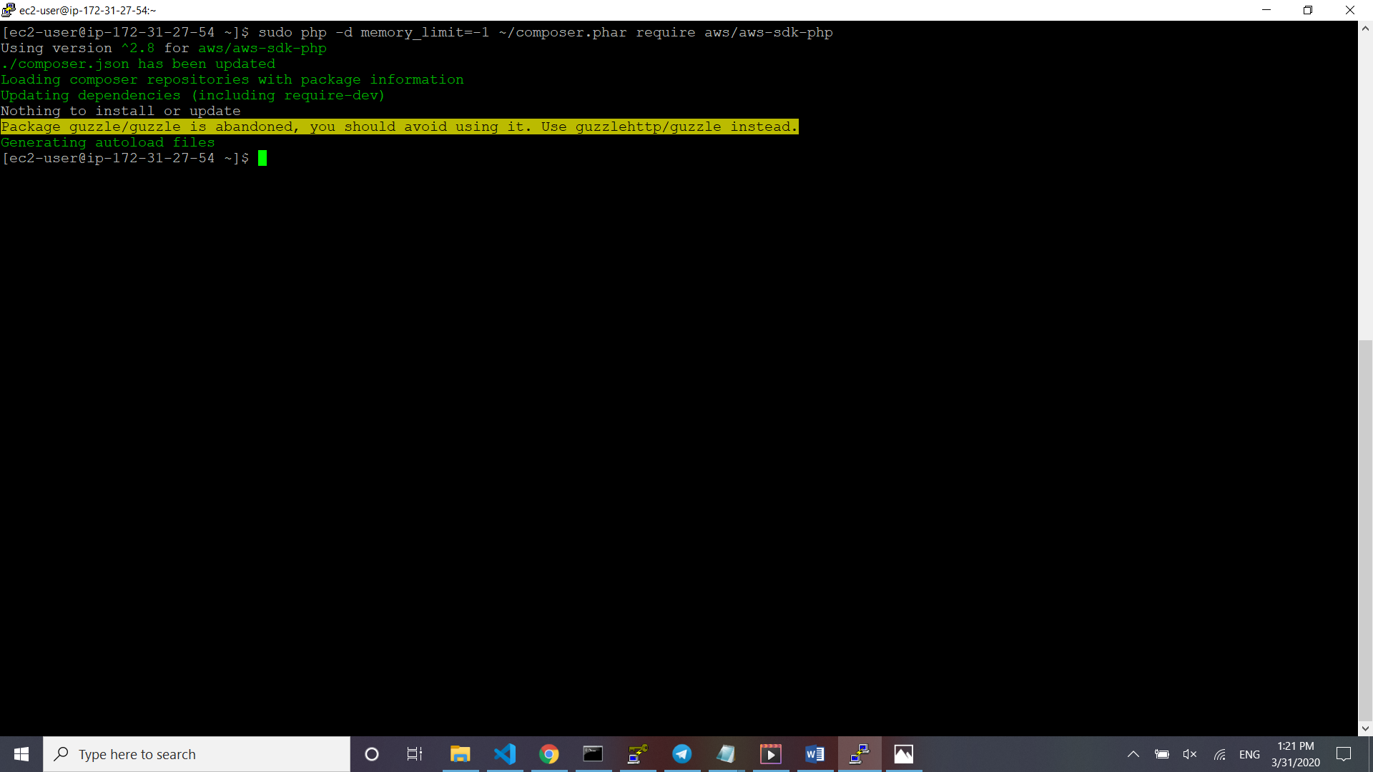

2. Installing php

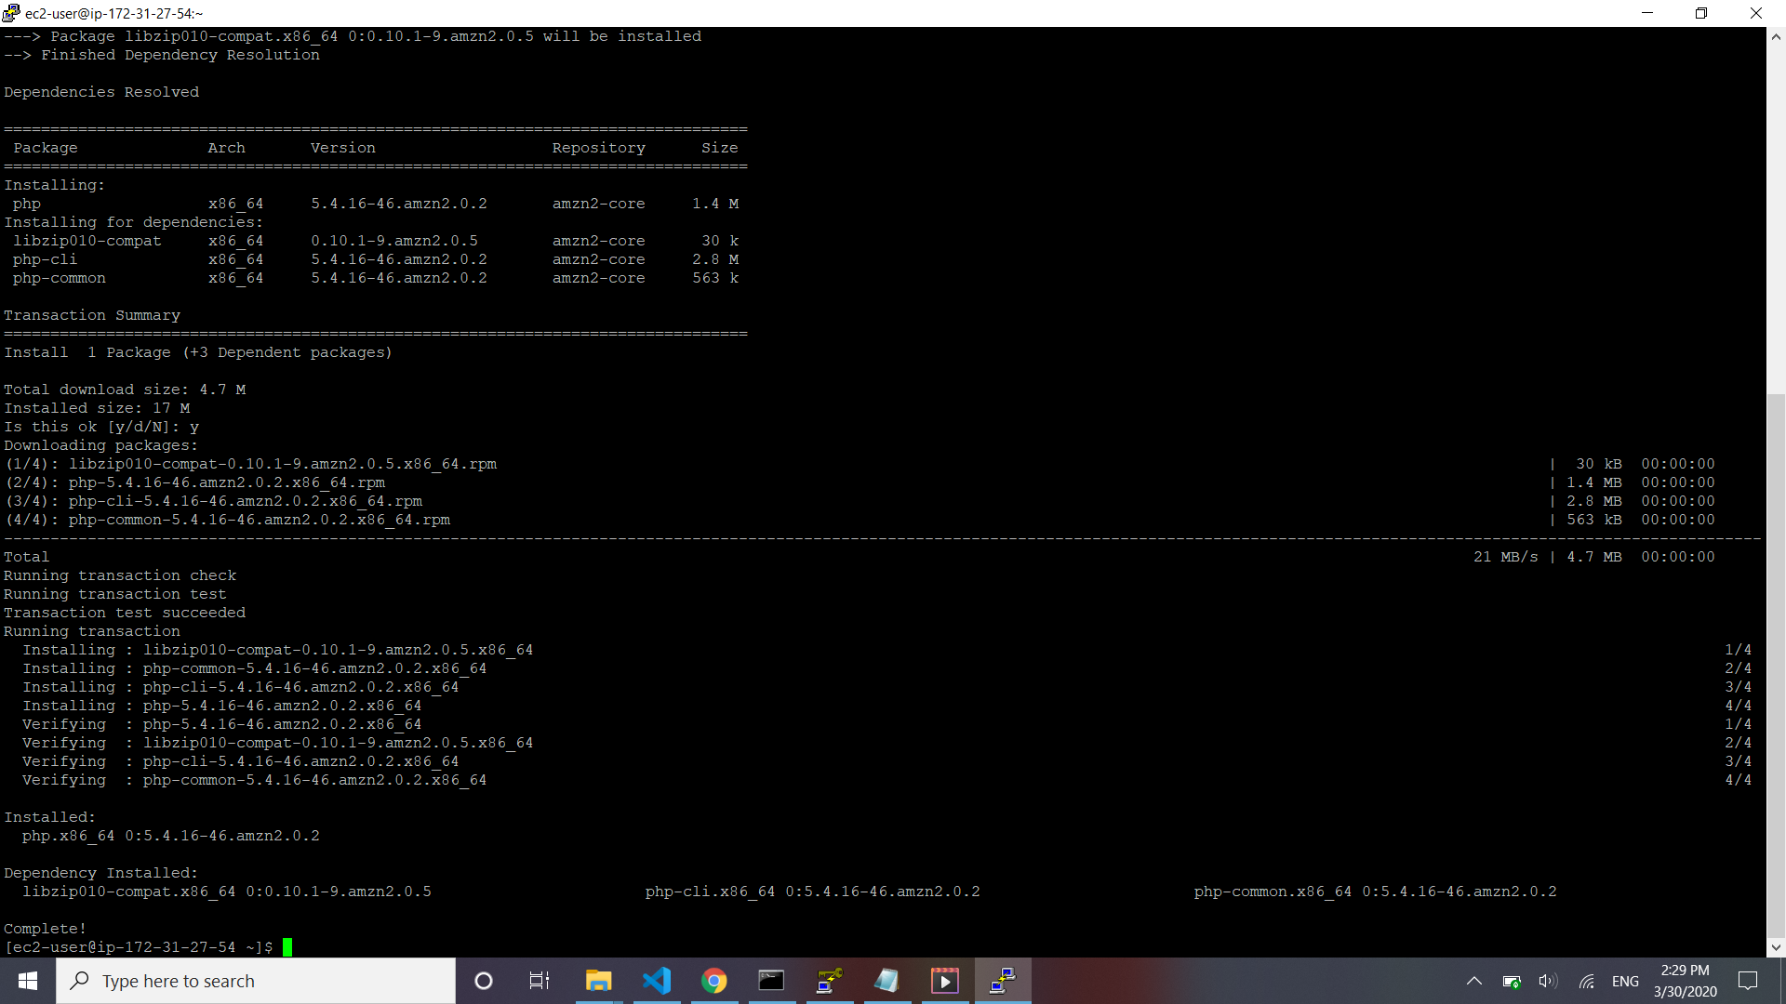

3. index.php file code

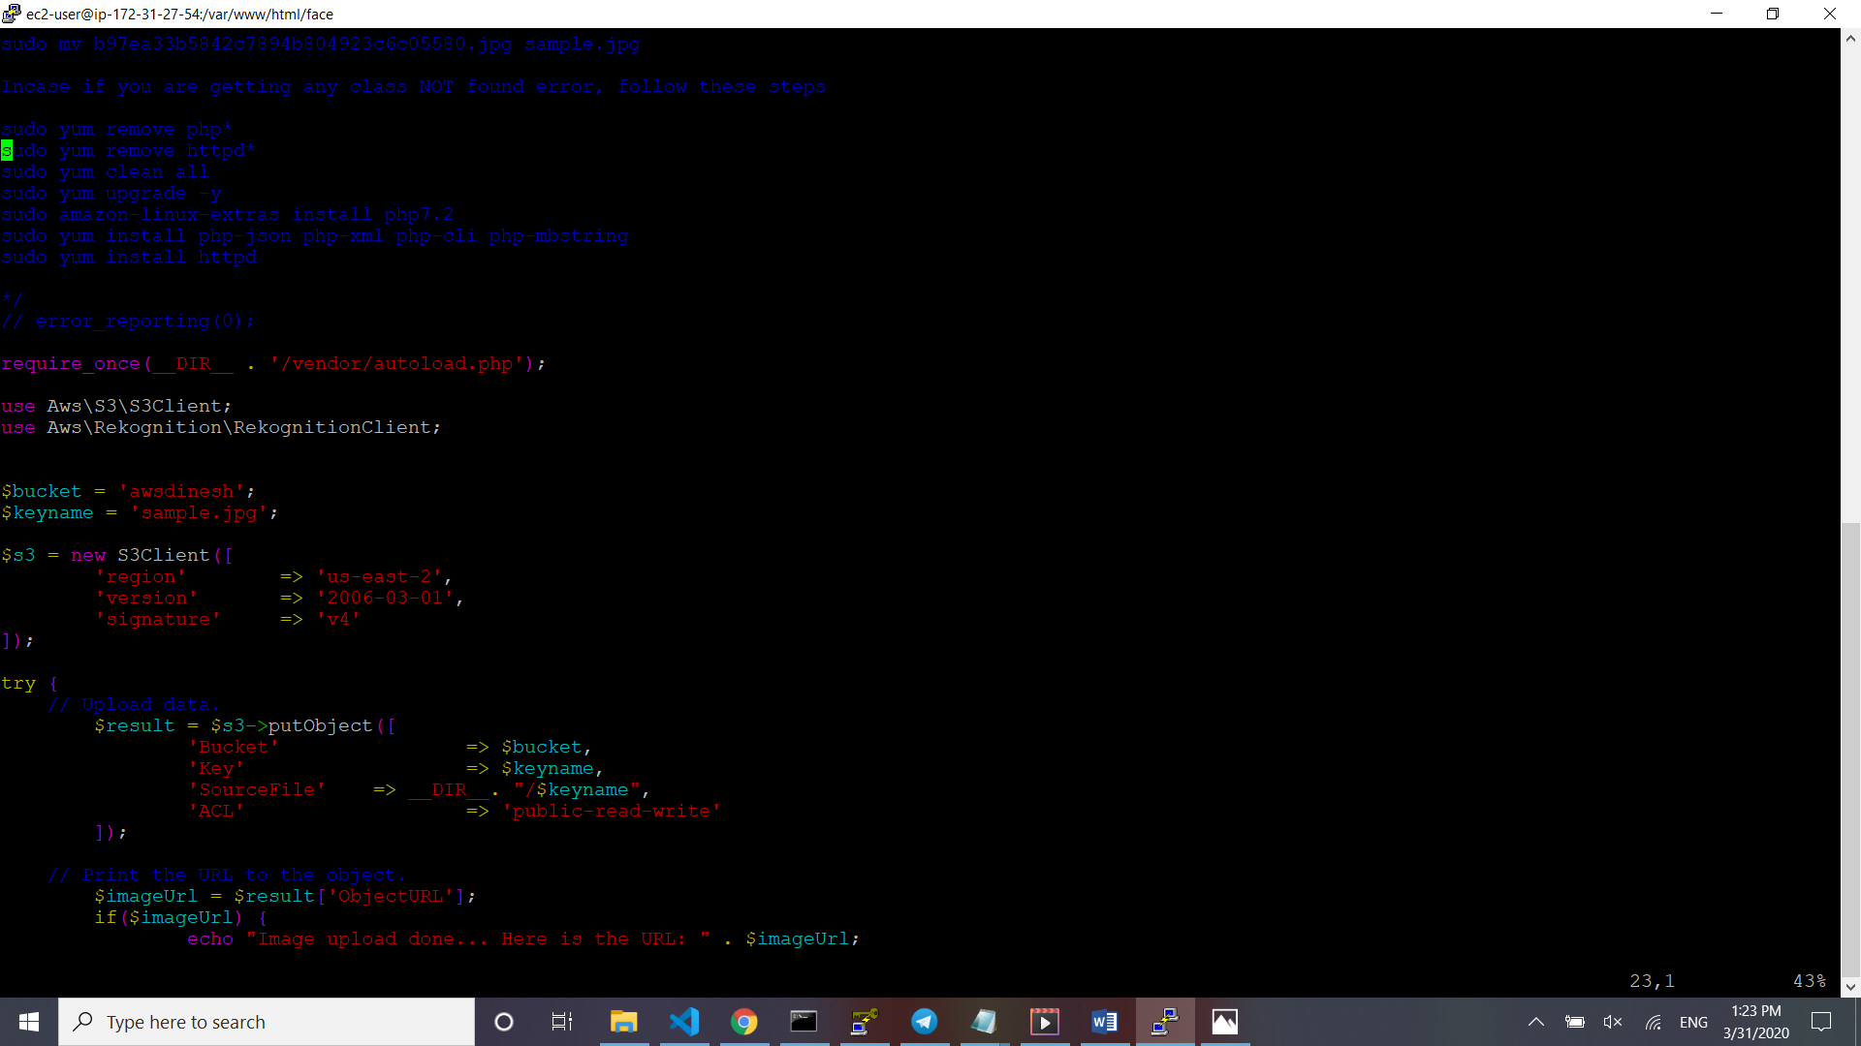

4. success screenshot

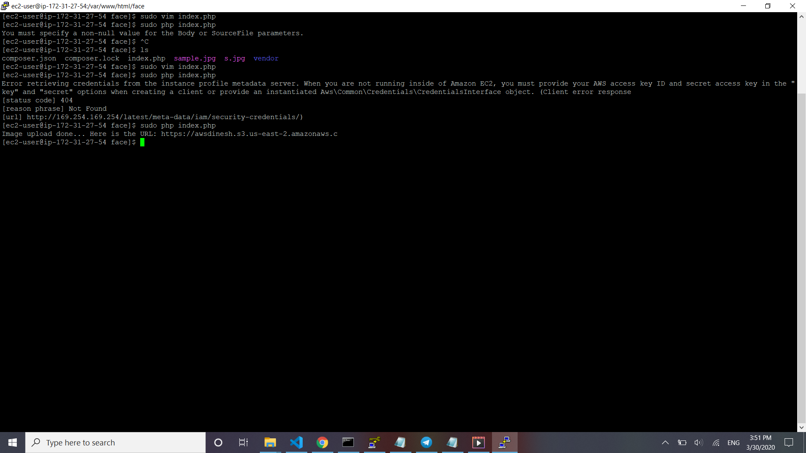

**Screenshots for EC2 & Rekognition**

1. Face Detect success screenshot

